About PVGames’ 2.5D Resources

This information is taken directly from the front page of my Patreon in order to reduce the number of times I need to write all of this up! If you want to see more information regarding these resources, feel free to check it out here: [https://www.patreon.com/PVGames](https://www.patreon.com/PVGames?fan_landing=true)

Tiles:  
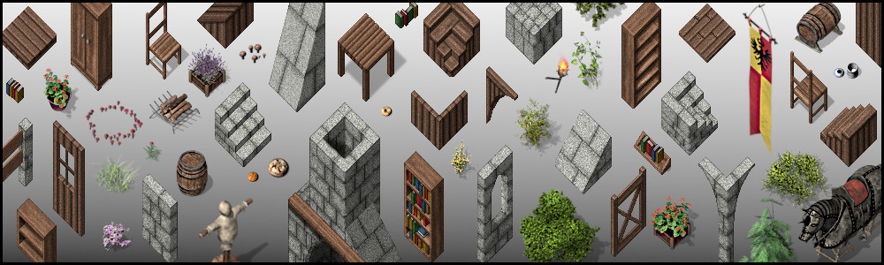  
The map tiles I create are modular and are designed to work together and be easily expanded upon. Although the average block has a 64x64 pixel base footprint, the tiles snap together easily on a 32x32 grid. The tiles come in a variety of shapes which allow you to create any kind of structure or atmosphere that you want. It's almost like playing with digital building blocks!  
  
Ground tiles come in larger 256x256 tileable chunks, as well as 256x256 decals. A tileable chunk allows you to fill a large area with a single ground texture easily, and the decals allow you to make more nuanced natural ground with faded transition edges.  
  
  
  
Character Resources:  
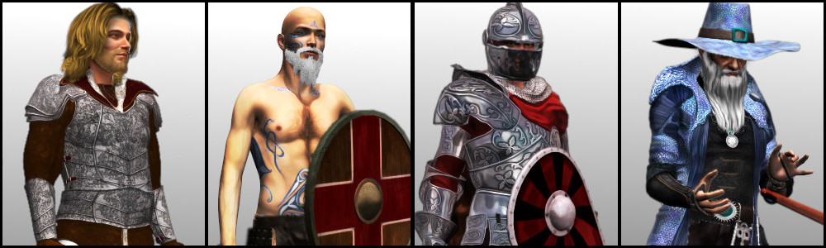  
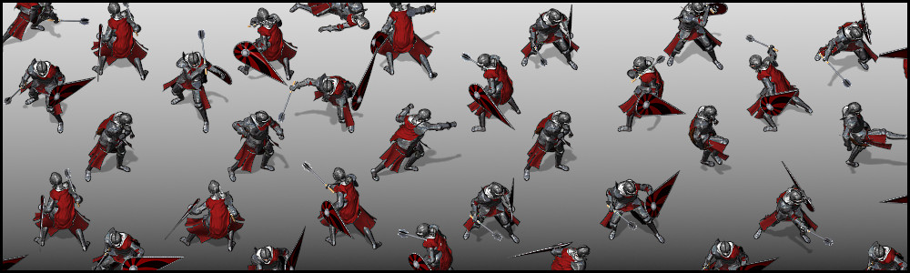  
Build your own characters! I've created (and will continue to create) resources for you to build your own heroes and villains, not to mention the townsfolk, for your games.   
  
All character pieces are in modular layers, so you can freely mix and match. You can take the hair from one set and combine it with the top from another, with the pants coming from yet a different character set! The combinations become nearly innumerable.   
  
Each character piece comes with over 70 2D animations, all in 8 directional facings. These animations range from walking and running to fighting, sitting, waiting around, sleeping, drinking, and so much more. Combat animations support all sorts of melee weapons, bows, crossbows, as well as various firearms like rifles, machine guns, and pistols.  
  
On top of this, each character piece comes with 24 high-res images to create custom face portraits, 24 high-res bust images to create custom busts, and 24 high-res paper doll images.  
  
The method in which these pieces are released is based on "character class" or "profession." In the above images, for example, are character pieces from the Battleguard, Berserker, Knight, and Mage from left to right respectively. Male and Female templates are both supported. Additional templates will be supported in the future (think Dwarves, aliens, and more!)  
  
Since a picture is worth a thousand words, here are two-thousand words showing a few of the paperdoll resources:  
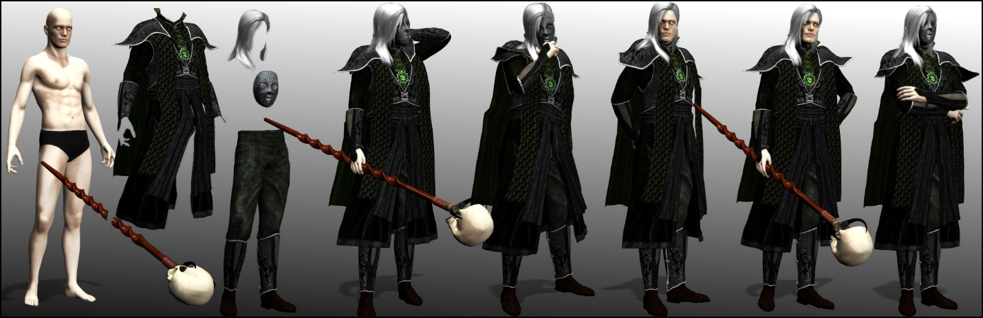  
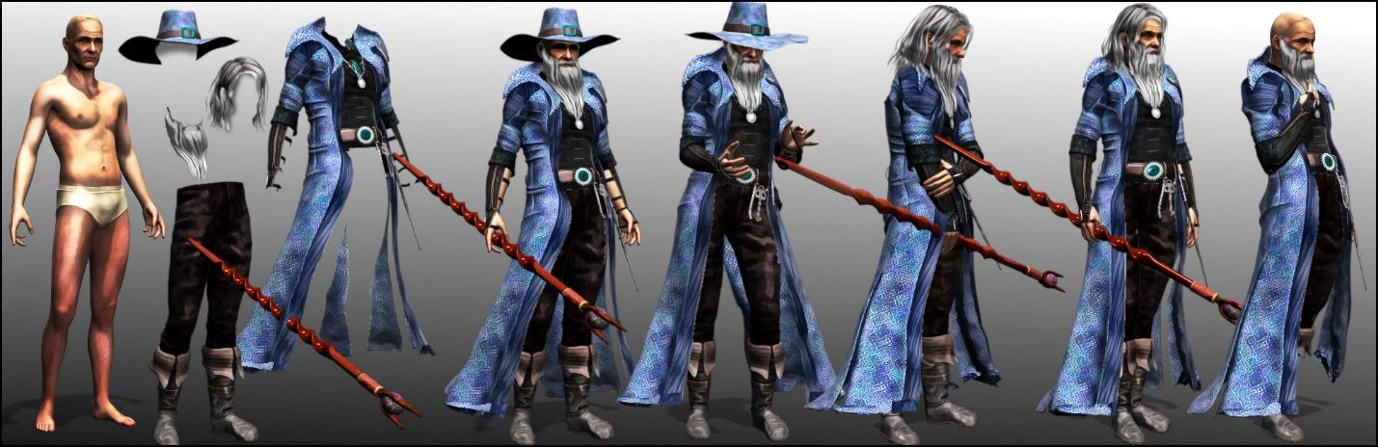  
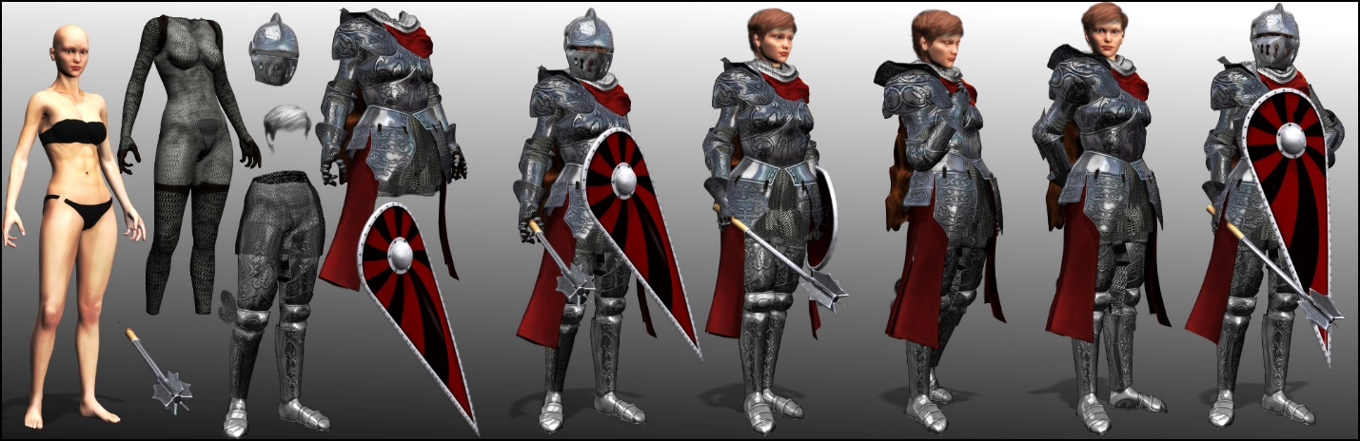  
  
  
  
Software:  
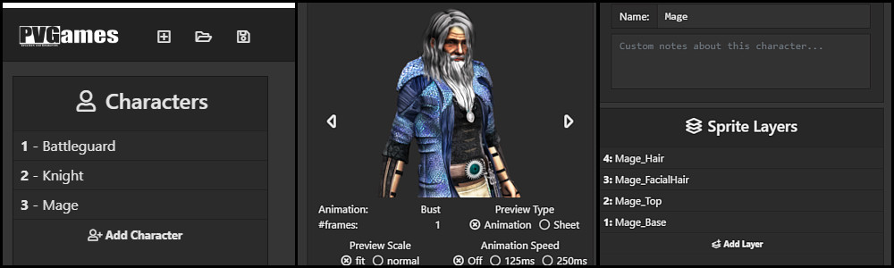  
Currently under development, this software will allow you to easily import new character building resources and use them to generate your own characters, complete with the ability to edit the layers (color, opacity, saturation, etc) of your character, preview the animations or static images, create project templates, customize exports, and more!  
  
The above images will most likely change as the development of the software progresses. This software will be available early to all Patrons, and released later for free. All work on the software is thanks to [Dekita RPG](https://www.dekitarpg.com/" \t "_blank).  
  
  
  
Monsters: *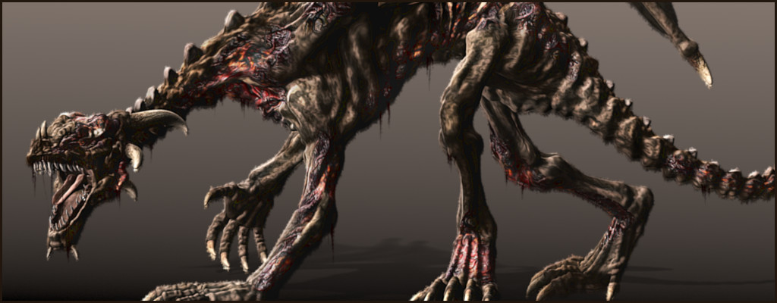*  
No game is complete without terrible baddies to defeat! These monster resources come with a number of 2D animations, though admittedly not as many as the human characters. But still, they have walking (and when necessary, running) animations, attacking animations, resting animations, death poses, and more, all in 8 directional facings. In addition, I create one or more high-res still images of the monsters with transparent background; these can be used as static battlers or used in promotional material, or whatever else you want to use them for!

Please refer to the link up above for additional information!

If you have any specific questions and want to get in touch with me, feel free to head over to my website, there are a number of options available to reach me! <http://www.pioneervalleygames.com/index.html>

Thank you kindly and happy building!

-Jesse